

PARALLEL AND DISTRIBUTED COMPUTING

**WORD COUNT USING OPEN MP**

**Semester Project Report**

Section: 5E

**Group Members:**

Uzair Ali 18K-1148

Hasan Shafiq 18K-1268

**Submitted to**: Ms. Nausheen Shoaib

Objective

Our main purpose is to show the difference between serial and parallel computing times.

## Introduction

In theory when a large task is divided among cores then the task completes fairly quickly as compared to if it was run only on one core (serially).

## Methodology

for this we have generated a text file using dictionary which will of great size (IN GBs) then we will split that file among the cores then count the word in each sub-file.

## Result

## (SCREEN SHOTS)

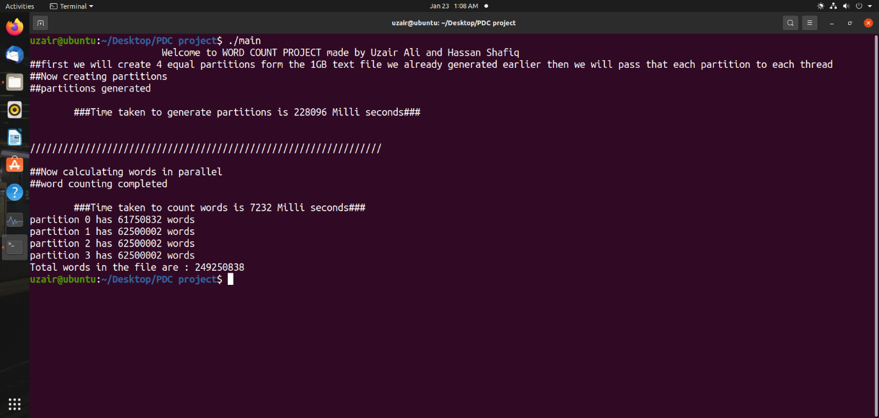

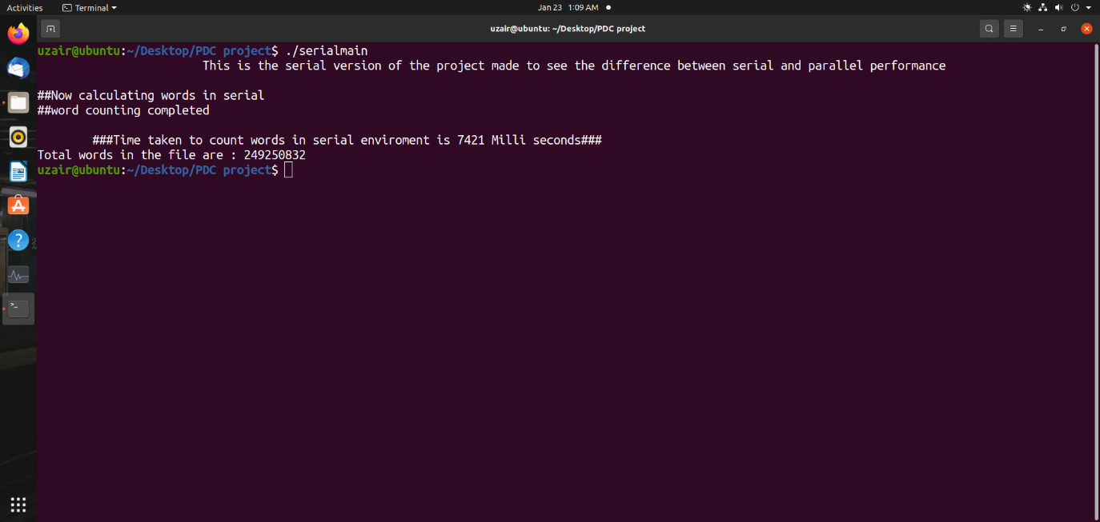

##As you can see the parallel code took less time which is 7232 milli seconds than serial code which is 7421 milli seconds ##

## Conclusion

In conclusion we can say that counting word in parallel will take less time than if it was run serially (proof in the Screen Shot). This difference grows exponentially when file size is increased.